**Lab 05 - Implement Intersite Connectivity**

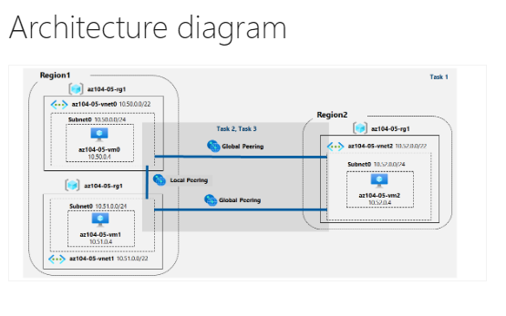

**Task 1: Provision the lab environment**

We are creating 3 virtual machines in separate virtual network

Opening power shell in azure

Upload files that were provided and change the password in the parameters file through power shell editor {}

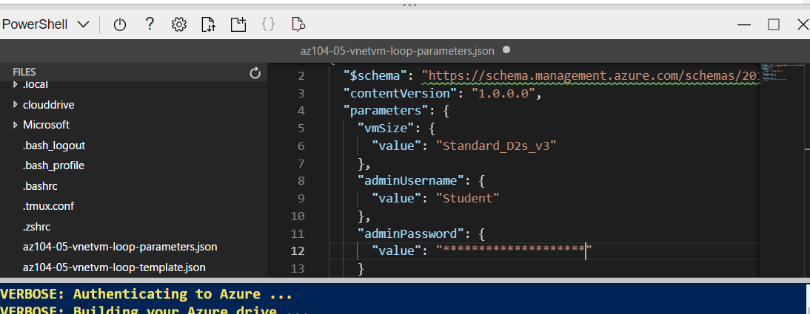

Running the following command will create the resource group for this lab

$location1 = 'eastus'

$location2 = 'westus'

$rgName = 'az104-05-rg1'

New-AzResourceGroup -Name $rgName -Location $location1

The first two virtual networks and a pair of virtual machines will be deployed in region 1- east us.  
The third virtual network and the third virtual machine will be deployed in the same resource group but another region -west us

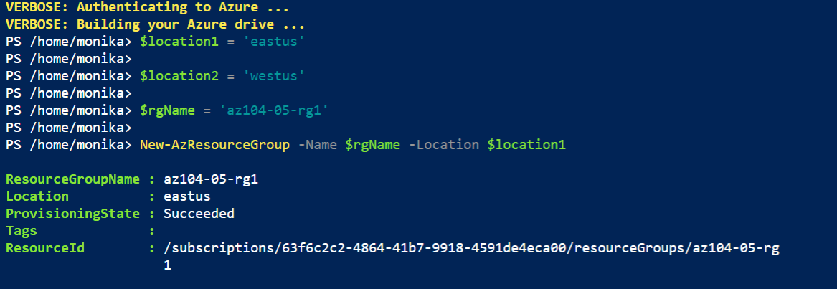

Next, we create three virtual networks and deploy virtual machines into them by using the template and parameter files that we uploaded at the beginning of the lab

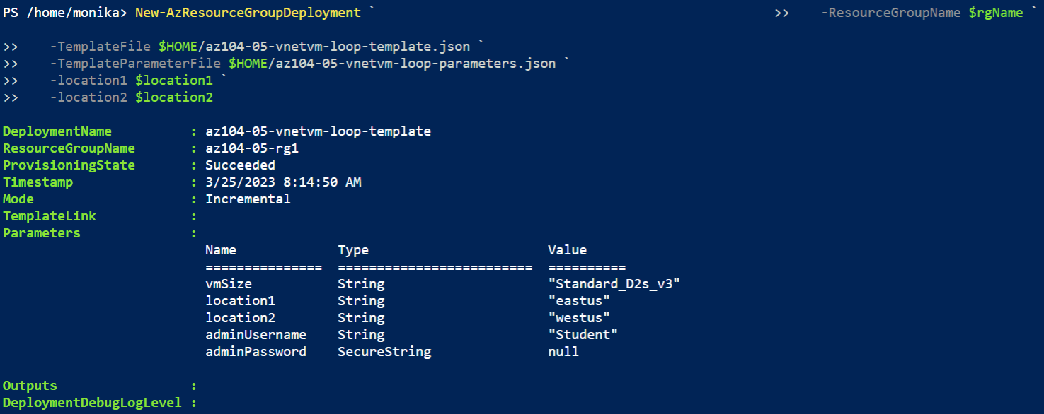

**Task 2: Configure local and global virtual network peering**

On the second task we will configure local and global peering between the virtual networks from the previous task

We can check that 3 virtual networks are already created with different location on the 3rd virtual network

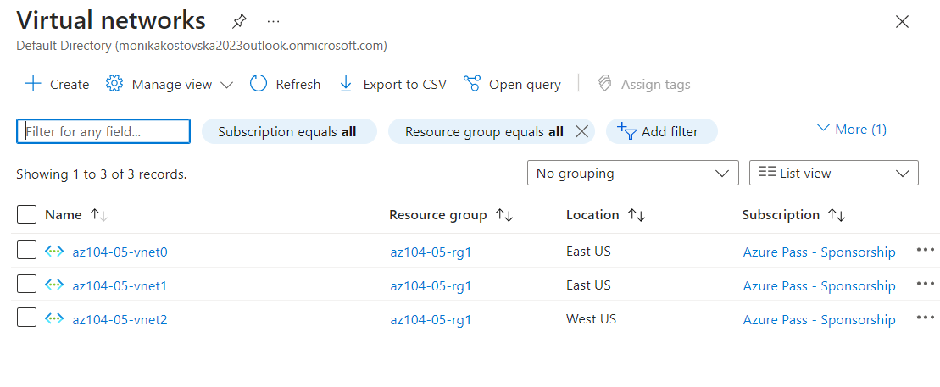

Next, we need to peer the first two virtual networks  
I run into an issue because the subscription was not showing up the virtual networks that were created and I was not able to peer them, but this can be resolved by running this code in power shell:

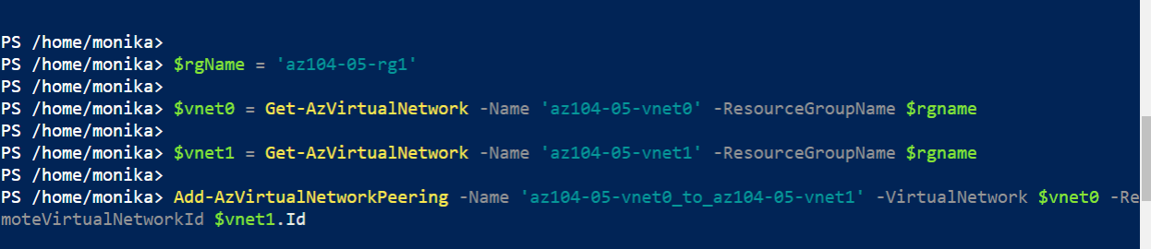

This way I configured the peering by running commands from power shell instead of adding a peer.

On this step we established two local peerings:  
 one from az104-05-vnet0 to az104-05-vnet1 and  
 the other from az104-05-vnet1 to az104-05-vnet0  
and we can see that the peering is created.

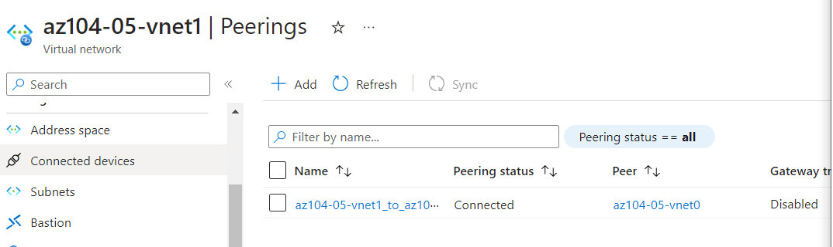

I had the same issue with adding the peer manually so I run the provided command In power shell

Next, we create two global peerings, one from az104-05-vnet0 to az104-05-vnet2 and the other from az104-05-vnet2 to az104-05-vnet0.

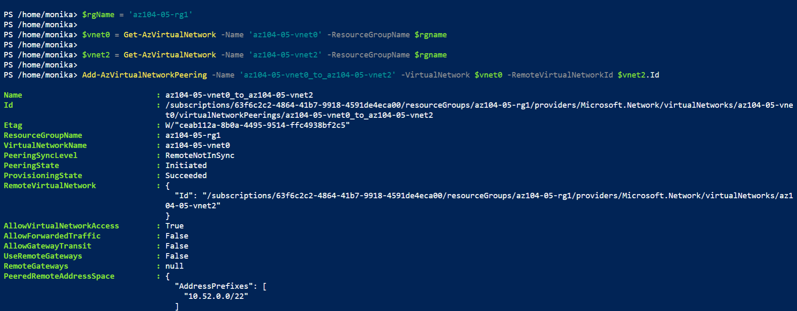

And we repeat the same with the second virtual network,we establish two global peerings -   
one from az104-05-vnet1 to az104-05-vnet2 and the other from az104-05-vnet2 to az104-05-vnet1.

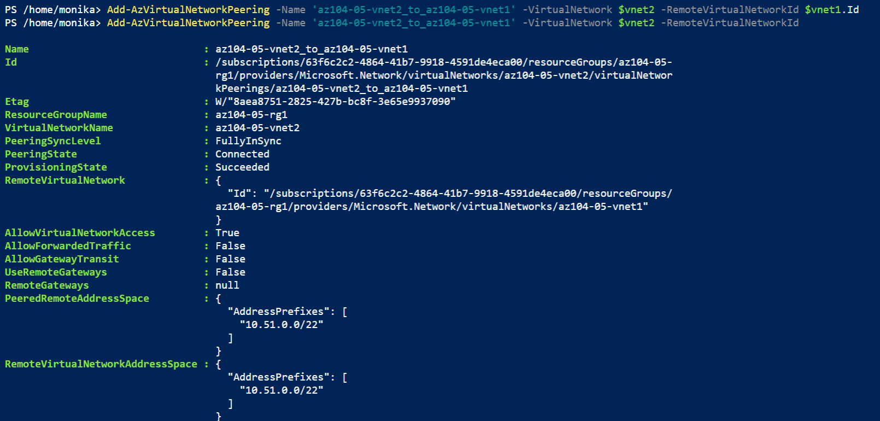

**Task 3: Test intersite connectivity**

Testing connectivity between virtual machines on the three virtual networks that were connected by local and global peering.

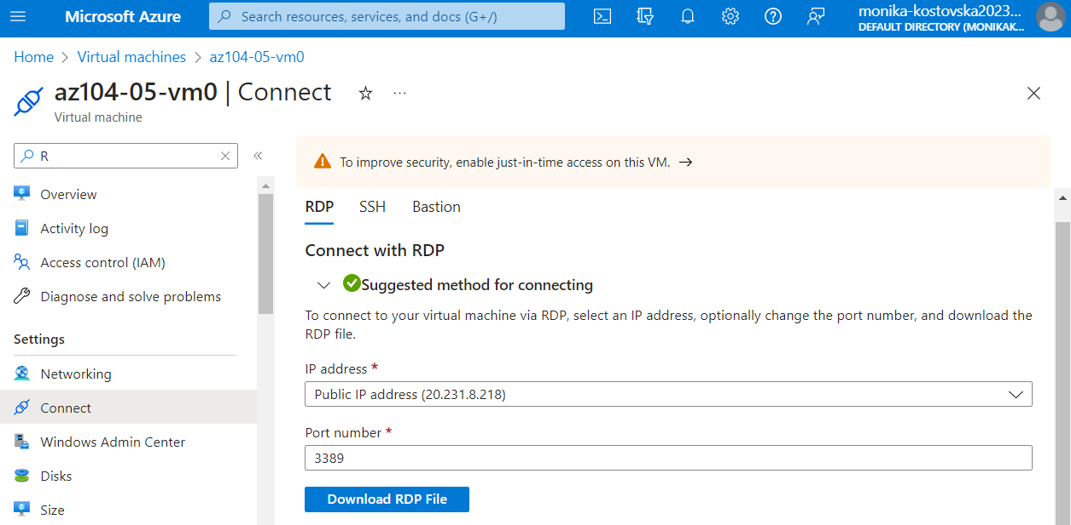

Downloading the RDP File and starting the remote desktop

We sign in by using the Student username and the password that we typed into the parameters file

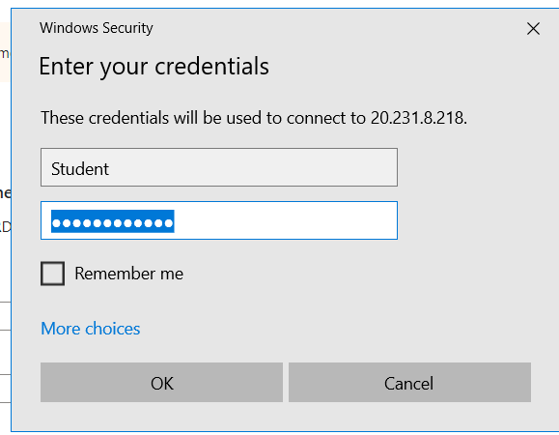

We enter into the remote desktop and we open power shell as admin, we can test the connectivity by running the command bellow

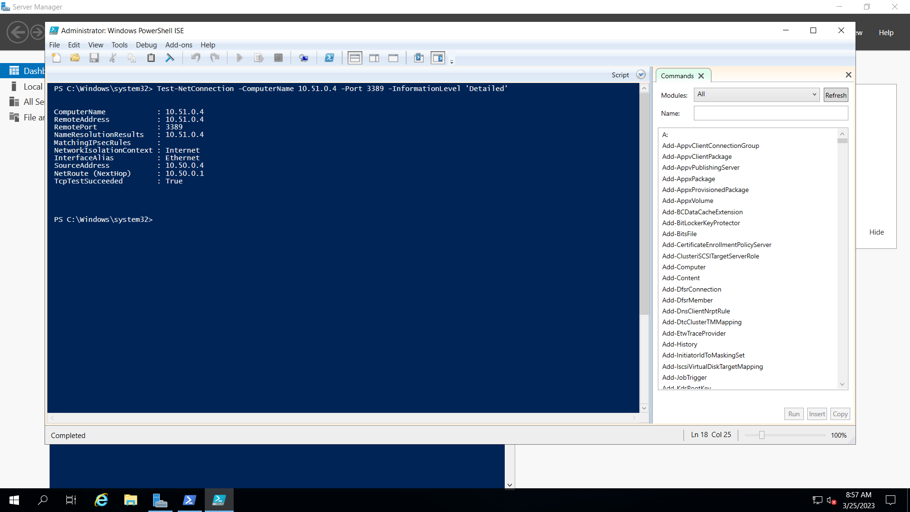

The connection was successful

We also test the connectivity to az104-05-vm2 with the second command ans it was succesful as well

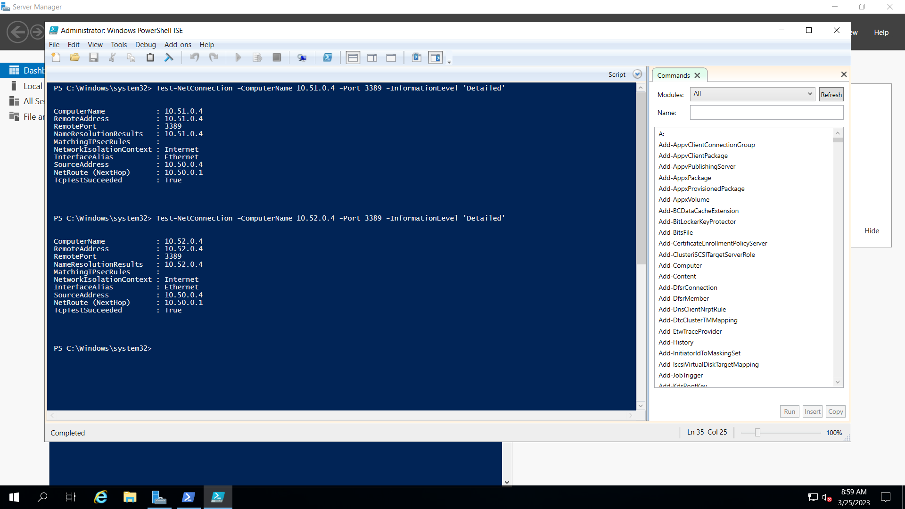

We are connecting the second virtual machine to see if the connection was successful

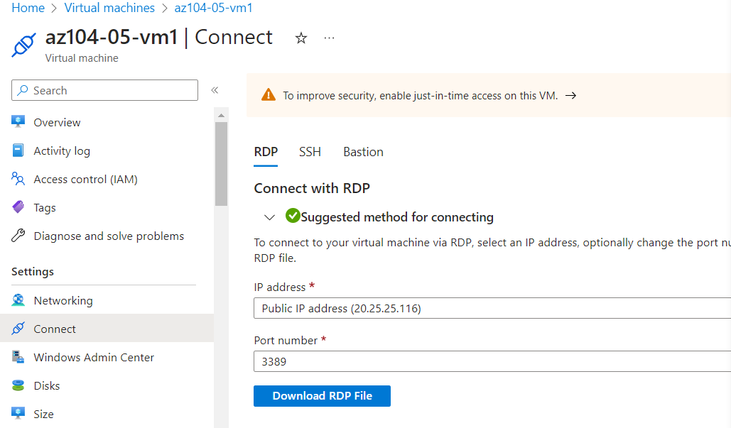

Downloading the RDP File and starting the remote desktop

We sign in by using the Student username and the password that we typed into the parameters file

After we enter into the remote desktop and we open power shell as admin, we can test the connectivity by running the command bellow

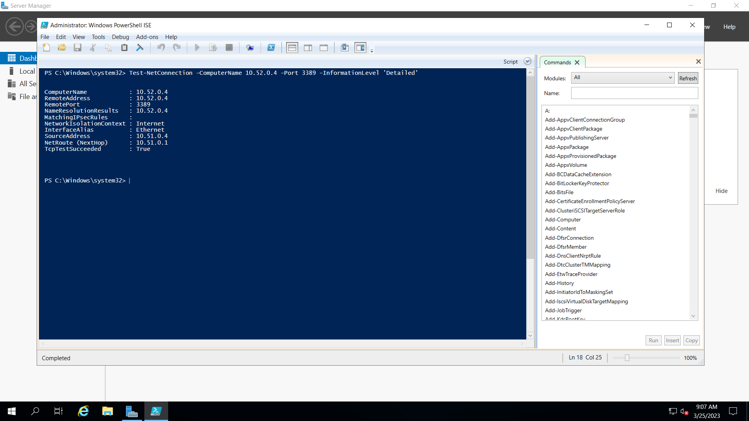

And the connection was successful.